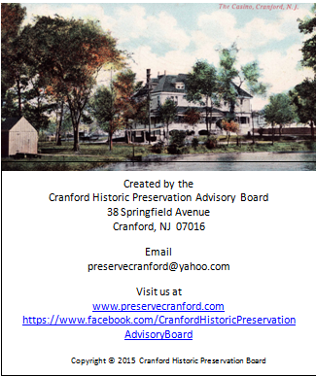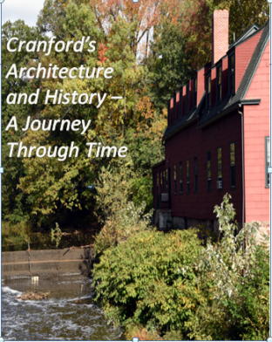

*Cranford’s History and Architecture – A Journey Through Time*

The Cranford Historic Preservation Advisory Board is proud to present “Cranford’s History and Architecture – A Journey Through Time”. The hour-long DVD highlights the character of Cranford, with examples of the rich variety of building styles that grace our neighborhoods, and reviews Cranford’s development, both architecturally and socially. The video was inspired by “An Architectural Tour of Cranford” which was written and produced in 1989 by David Holden.

NAME: _________________________________________________________

ADDRESS: _____________________________________________________

CITY: _________________________ STATE: ________ ZIP:______

EMAIL: ________________________________________________________

PHONE: _______________________________________________________

Cranford’s History and Architecture DVD _____ X $15.00 each = $ ________

Shipping charge per DVD _____ X $ 3.95 each = $ ________

TOTAL $ ________

Please send this form and your check (made payable to “Cranford Historic Preservation” ) to:

Cranford’s History and Architecture

Cranford Historic Preservation Advisory Board

8 Springfield Avenue

Cranford, NJ 07016